

SIMATS ENGINEERING

Saveetha Institute of Medical and Technical Sciences
Chennai- 602105

Student Name:K Phani Sridhar Yogi Reg. No.: 192311091 Course Code: CSA4308 Slot: A
Course Name: Internet Programming
Course Faculty: Dr. K Rajagopal
Project Title: A Context-Aware Smart City Information Portal for Intelligent Citizen Service Delivery and Public Engagement
Module Photographs:
Module Photo  Module 2-City Services | Individual student contribution module work in the project | Presentation Image
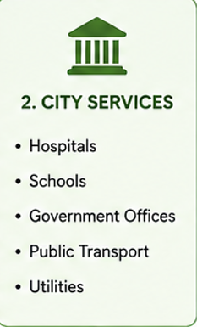 | 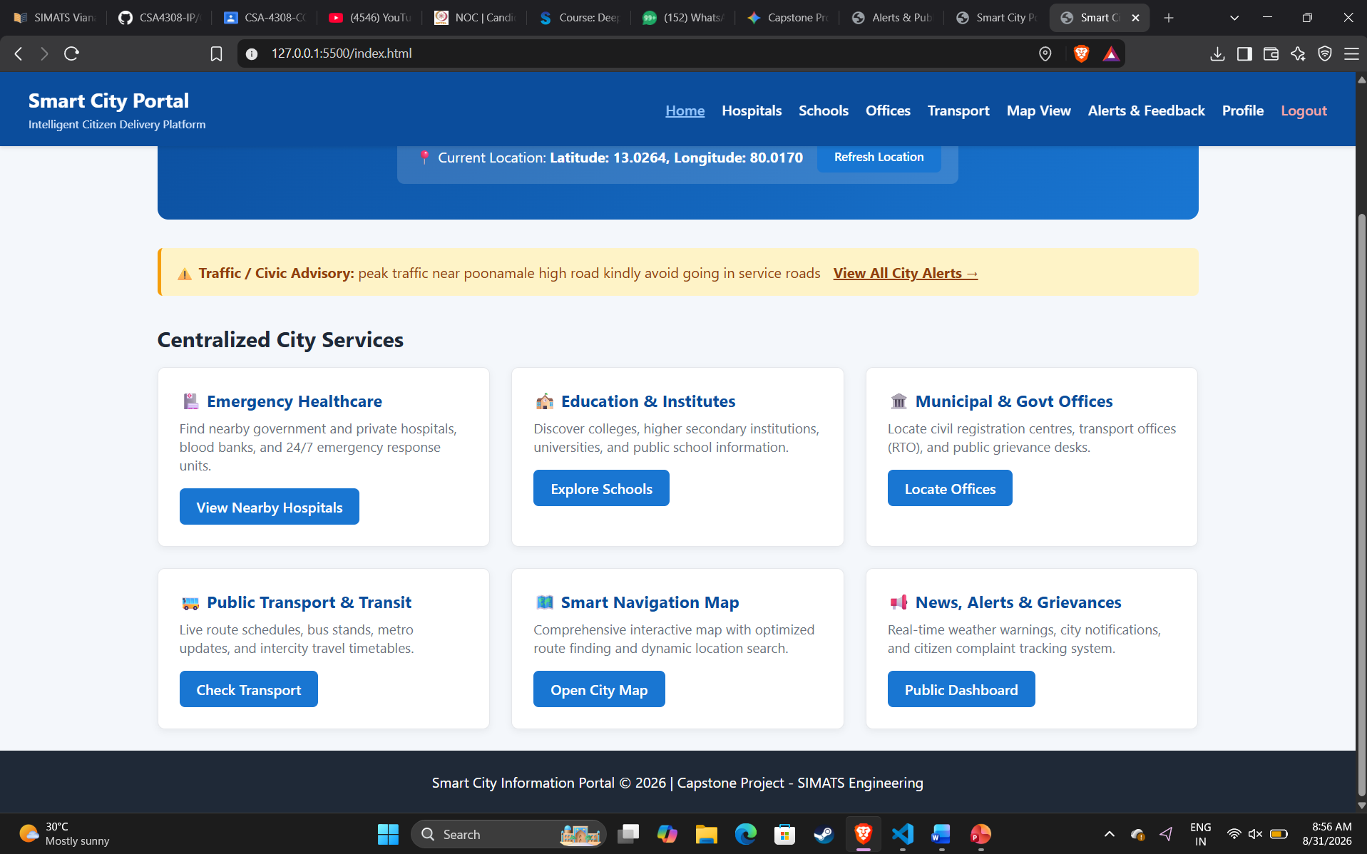 | 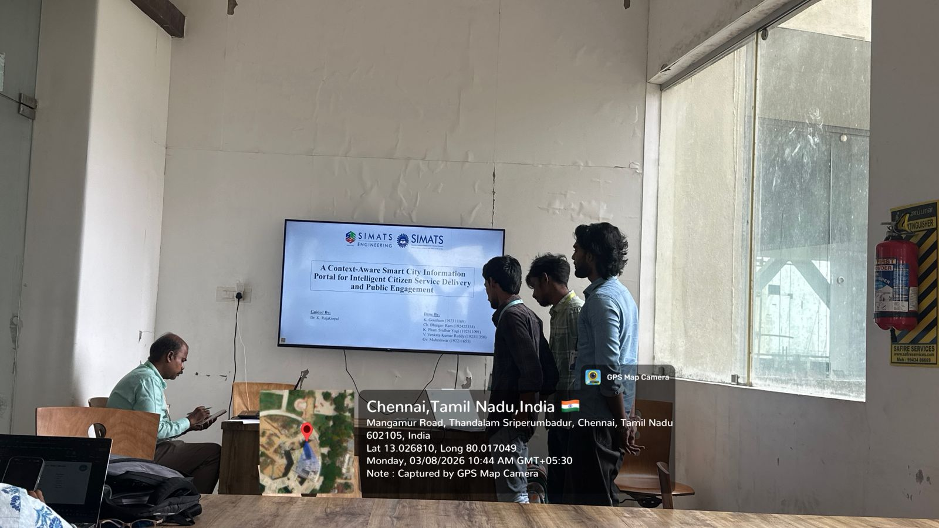
Project Description: Module 2- Access detailed information about nearby hospitals and healthcare facilities.
The project “A Context-Aware Smart City Information Portal for Intelligent Citizen Service Delivery and Public Engagement” focuses on providing a centralized digital platform for accessing essential urban services and municipal information. The system replaces scattered city portals by offering a unified interface for locating nearby hospitals, schools, government offices, and public transit hubs in real time. Using client-side geolocation and context-aware intelligence, the portal detects the user’s location to calculate exact distances and render interactive maps with route guidance. Citizens can access live emergency broadcasts, traffic notices, and weather advisories published directly by city officials. The platform features an integrated grievance redressal module that allows users to register municipal complaints, track resolution tickets, and participate in civic polls. On the administrative side, authorities utilize a dedicated command dashboard to monitor incoming public issues, mark tickets as resolved, register new public facilities, and broadcast critical city-wide alerts. Overall, the project combines geolocation processing, interactive mapping, role-based access control, and two-way municipal synchronization to improve citizen convenience, transparency, and urban governance.

Student Signature Guide Signature

